SOAL ELEKTRONIKA ANALOG
BAB 3 Persimpangan Bipolar Transistor
Nama : Kayla Puteri Gunawan
NIM : 211331010
Kelas : 1A – TTE

- What names are applied to the two types of BJT transistors? Sketch the basic construction of each and label the various minority and majority carriers in each. Draw the graphic symbol next to each. Is any of this information altered by changing from a silicon to a germanium base?
(Nama apa yang diterapkan pada kedua jenis transistor BJT tersebut? Sketsa konstruksi dasar dari masing-masing dan beri label berbagai pembawa minoritas dan mayoritas di masing-masing. Gambar simbol grafik selanjutnya untuk masing-masing. Apakah ada dari informasi ini yang diubah dengan mengubah dari silikon ke basis germanium? )
Jawab:
Kedua jenis Bipolar Junction Transistor (BITS) adalah,
• Transistor PNP
• Transistor NPN Pada transistor PNP, semikonduktor tipe-n ditempatkan di antara dua semikonduktor tipe-p pada transistor NPN, semikonduktor tipe-p ditempatkan di antara dua semikonduktor tipe n

- What is the major difference between a bipolar and a unipolar device?
(Apa perbedaan utama antara perangkat bipolar dan unipolar?)
Jawab:
Transistor bipolar menggunakan hole dan elektron pada proses injeksi atau perubahan aliran, sedangkan perangkat unipolar menggunakan elektron atau hole, tetapi tidak keduanya dalam proses perubahan.

- How must the two transistor junctions be biased for proper transistor amplifier operation?
(Bagaimana dua persimpangan transistor harus bias untuk operasi penguat transistor yang tepat?)
Jawab: Bias maju dan bias mundur

- What is the source of the leakage current in a transistor?
(Apa sumber arus bocor pada transistor?)
Jawab: arus bocor Ie0 adalah arus pembawa minoritas dalam kumpulan

- Sketch a figure similar to Fig. 3.3 for the forward-biased junction of an npn transistor. Describe the resulting carrier motion.
(Buat sketsa gambar yang mirip dengan Gambar 3.3 untuk sambungan bias maju dari transistor npn. Menggambarkan gerakan pembawa yang dihasilkan.)
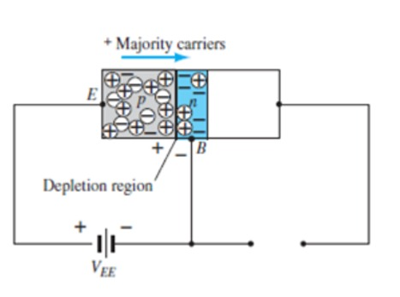
Jawab :

- Sketch a figure similar to Fig. 3.4 for the reverse-biased junction of an npn transistor. Describe the resulting carrier motion.
(Buat sketsa gambar yang mirip dengan Gambar 3.4 untuk sambungan bias mundur dari transistor npn. Menggambarkan gerakan pembawa yang dihasilkan.)
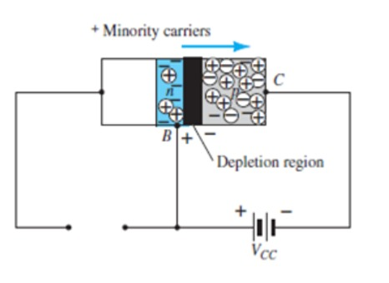
Jawab :

- Sketch a figure similar to Fig. 3.5 for the majority- and minority-carrier flow of an npn transistor. Describe the resulting carrier motion.
(Buat sketsa gambar yang mirip dengan Gambar 3.5 untuk aliran pembawa mayoritas dan minoritas dari transistor npn. Jelaskan gerak pembawa yang dihasilkan.)

- Which of the transistor currents is always the largest? Which is always the smallest? Which two currents are relatively close in magnitude?
(Manakah dari arus transistor yang selalu terbesar? Manakah yang selalu paling kecil? Yang
dua arus yang besarnya relatif dekat?)
Jawab:
IE yang terpajang
IB yang terpendek
IE . IB

- If the emitter current of a transistor is 8 mA and IB is 1/100 of IC, determine the levels of IC and IB.
(Jika arus emitor transistor adalah 8 mA dan IB adalah 1/100 IC, tentukan level IC
dan IB.)
Jawab:
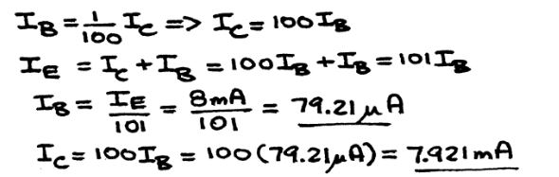

- From memory, sketch the transistor symbol for a pnp and an npn transistor, and then insert the conventional flow direction for each current.
(Dari memori, buat sketsa simbol transistor untuk transistor pnp dan transistor npn, lalu masukkan arah aliran konvensional untuk setiap arus.)

- Using the characteristics of Fig. 3.7, determine V_{BE} at I_{E} 5 mA for V_{CB} 1, 10, and 20 V. Is it reasonable to assume on an approximate basis that V_{CB} has only a slight effect on the relationship between V_{BE} and I_{E}?
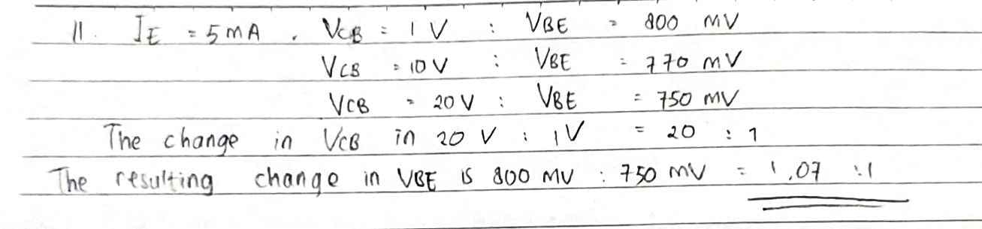

- (a) Determine the average ac resistance for the characteristics of Fig. 3.10b.
  - For networks in which the magnitude of the resistive elements is typically in kilohms, isthe approximation of Fig. 3.10c a valid one [based on the results of part (a)]?

- (a) Using the characteristics of Fig. 3.8, determine the resulting collector current if I_{E} 4.5 mA and V_{CB} 4 V.
  - Repeat part (a) for I_{E} 4.5 mA and V_{CB} 16 V.
  - How have the changes in V_{CB} affected the resulting level of I_{C}?
  - On an approximate basis, how are I_{E} and I_{C} related based on the results above?
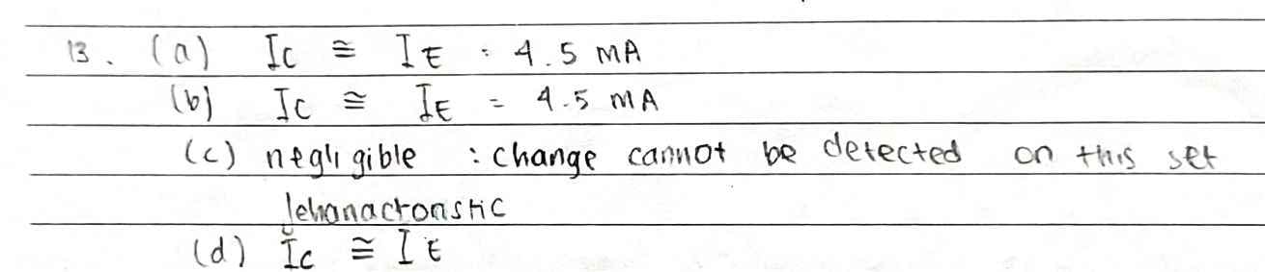
- (a) Using the characteristics of Figs. 3.7 and 3.8, determine I_{C} if V_{CB} 10 V and V_{BE} 800 mV.
  - Determine V_{BE} if I_{C} 5 mA and V_{CB} 10 V.
  - Repeat part (b) using the characteristics of Fig. 3.10b.
  - Repeat part (b) using the characteristics of Fig. 3.10c.
  - Compare the solutions for V_{BE} for parts (b), (c), and (d). Can the difference be ignored if voltage levels greater than a few volts are typically encountered?
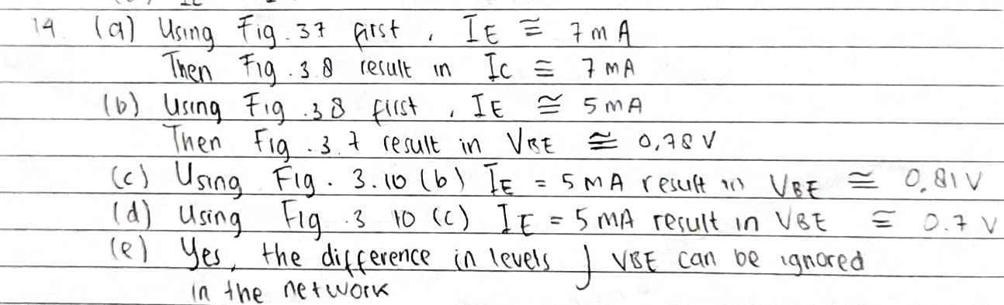

- (a) Given an _{dc} of 0.998, determine I_{C} if I_{E} 4 mA. (b) Determine _{dc} if I_{E} 2.8 mA and I_{B} 20 A. (c) Find I_{E} if I_{B} 40 A and _{dc} is 0.98.
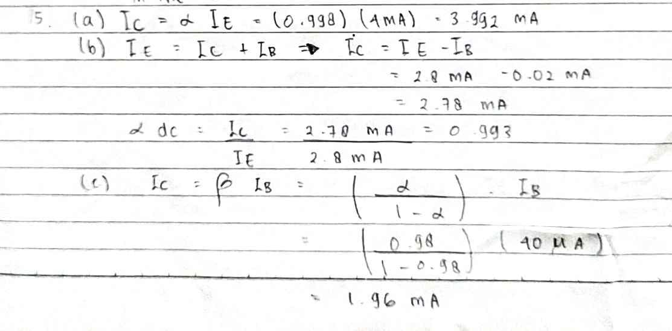
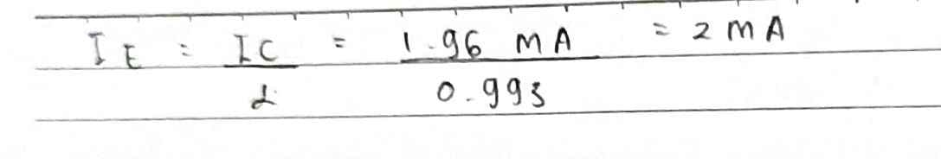
- From memory, and memory only, sketch the common-base BJT transistor configuration (for npn and pnp) and indicate the polarity of the applied bias and resulting current directions.
- Calculate the voltage gain (A_{v} V_{L}/V_{i}) for the network of Fig. 3.12 if V_{i} 500 mV and R 1 k. (The other circuit values remain the same.)
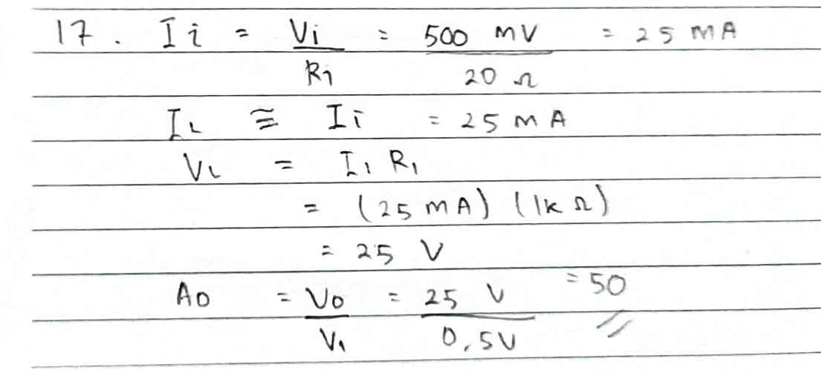

- Calculate the voltage gain (A_{v} V_{L}/V_{i}) for the network of Fig. 3.12 if the source has an internal resistance of 100 in series with V_{i}.
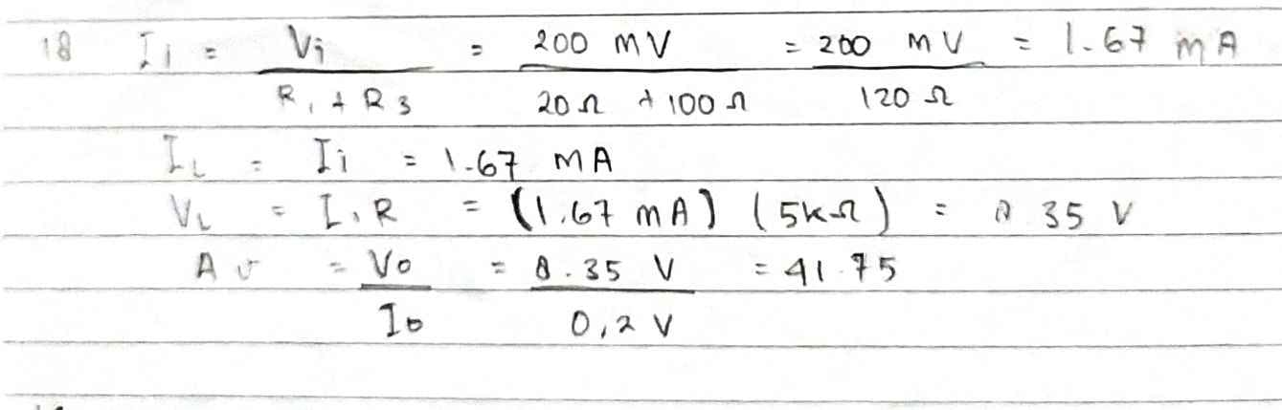
- Define I_{CBO} and I_{CEO}. How are they different? How are they related? Are they typically close in magnitude?
- Using the characteristics of Fig. 3.14:
  - Find the value of I_{C} corresponding to V_{BE} 750 mV and V_{CE} 5 V.
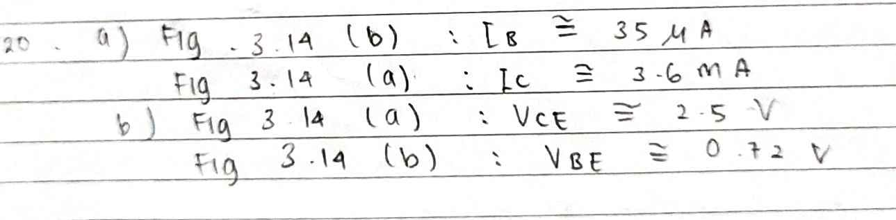
  - Find the value of V_{CE} and V_{BE} corresponding to I_{C} 3 mA and I_{B} 30 A.

21. (a) For the common-emitter characteristics of Fig. 3.14, find the dc beta at an operating point of VCE 8 V and IC 2 mA.
(b) Find the value of corresponding to this operating point.
(c) At VCE 8 V, find the corresponding value of ICEO.
(d) Calculate the approximate value of ICBO using the dc beta value obtained in part (a).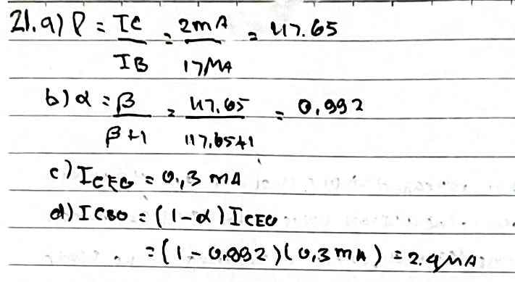
22. (a) Using the characteristics of Fig. 3.14a, determine ICEO at VCE 10 V.
(b) Determine dc at IB 10 A and VCE 10 V.
(c) Using the dc determined in part (b), calculate ICBO.
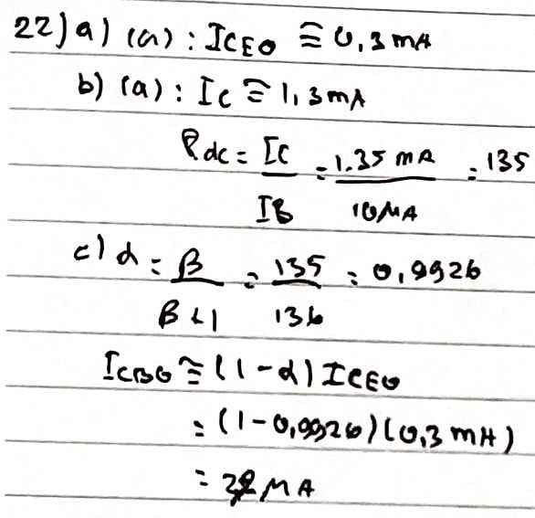
23. (a) Using the characteristics of Fig. 3.14a, determine dc at IB 80 A and VCE 5 V.
(b) Repeat part (a) at IB 5 A and VCE 15 V.
(c) Repeat part (a) at IB 30 A and VCE 10 V.
(d) Reviewing the results of parts (a) through (c), does the value of dc change from point to point on the characteristics? Where were the higher values found? Can you develop any general conclusions about the value of dc on a set of characteristics such as those provided in Fig. 3.14a
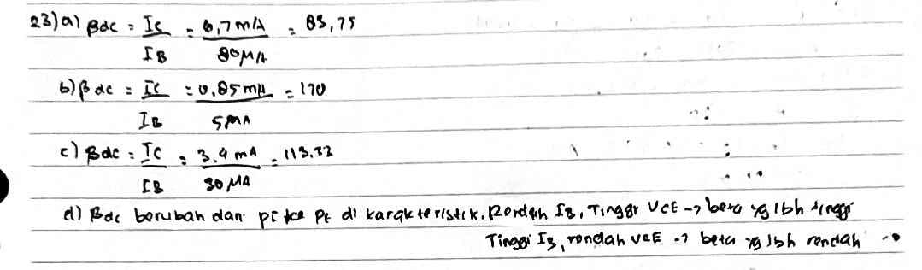
24. (a) Using the characteristics of Fig. 3.14a, determine ac at IB 80 A and VCE 5 V.
(b) Repeat part (a) at IB 5 A and VCE 15 V.
(c) Repeat part (a) at IB 30 A and VCE 10 V.
(d) Reviewing the results of parts (a) through (c), does the value of ac change from point to point on the characteristics? Where are the high values located? Can you develop any general conclusions about the value of ac on a set of collector characteristics?
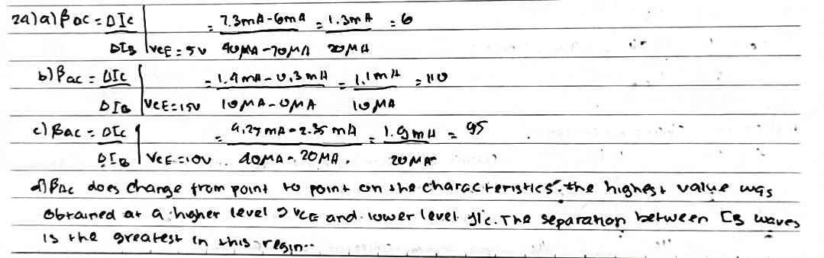
(e) The chosen points in this exercise are the same as those employed in Problem 23. If Problem 23 was performed, compare the levels
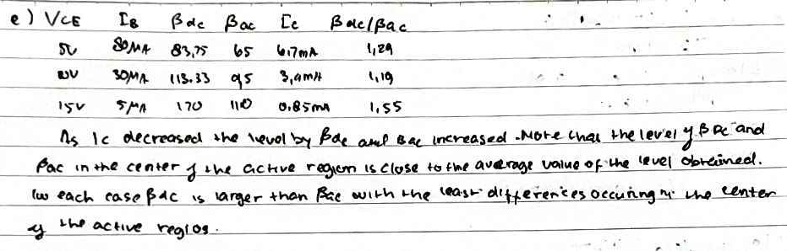
25. Using the characteristics of Fig. 3.14a, determine dc at IB 25 A and VCE 10 V. Then calculate dc and the resulting level of IE. (Use the level of IC determined by IC dcIB.)
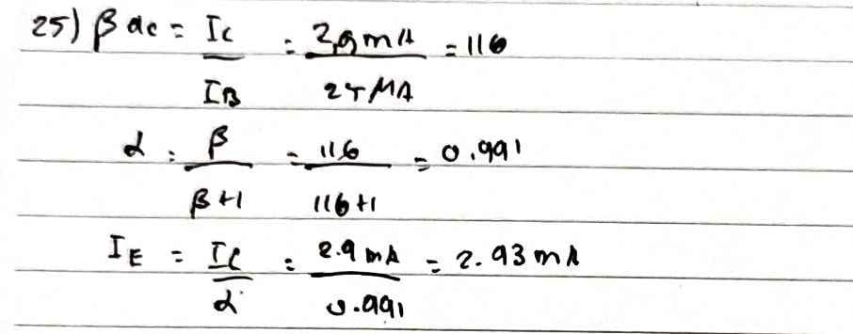
26. (a) Given that dc 0.987, determine the corresponding value of dc.
(b) Given dc 120, determine the corresponding value of
(c) Given that dc 180 and IC 2.0 mA, find IE and IB.
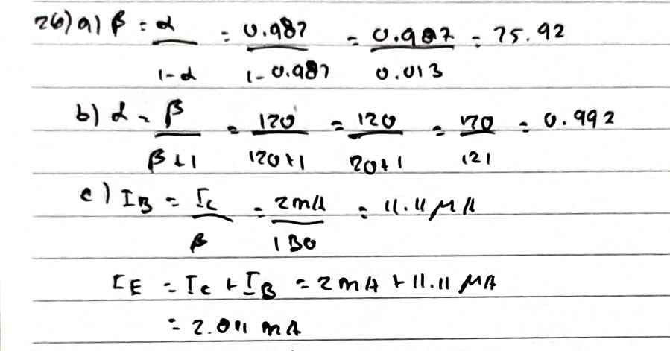
27. From memory, and memory only, sketch the common-emitter configuration (for npn and pnp) and insert the proper biasing arrangement with the resulting current directions for IB, IC, and IE.
28. An input voltage of 2 V rms (measured from base to ground) is applied to the circuit of Fig. 3.21. Assuming that the emitter voltage follows the base voltage exactly and that Vbe (rms) 0.1 V, calculate the circuit voltage amplification (Av Vo /Vi) and emitter current for RE 1 k. 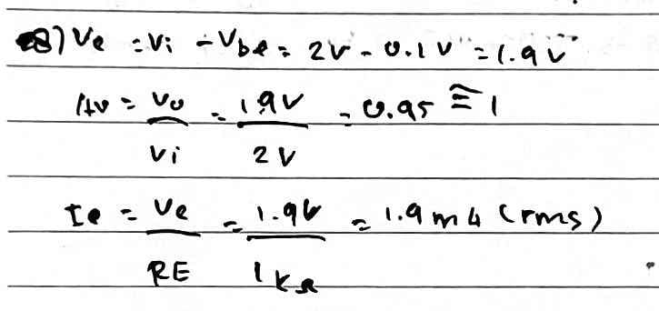
29. For a transistor having the characteristics of Fig. 3.14, sketch the input and output characteristics of the common-collector configuration.
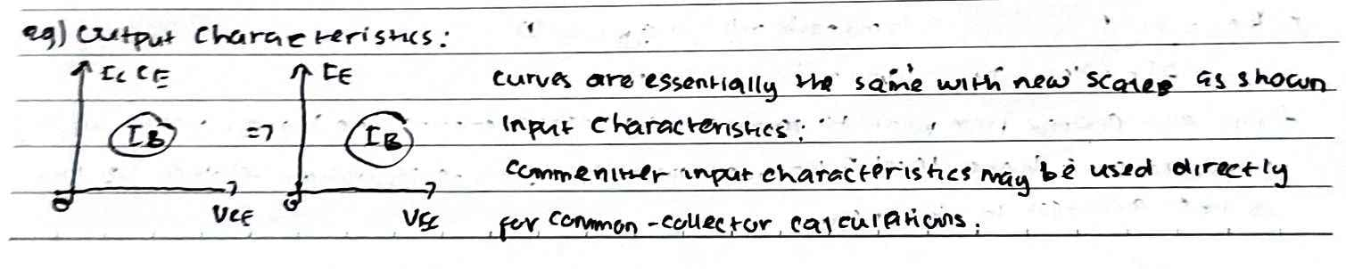
30. Determine the region of operation for a transistor having the characteristics of Fig. 3.14 if ICmax 7 mA, VCEmax 17 V, and PCmax 40 mW
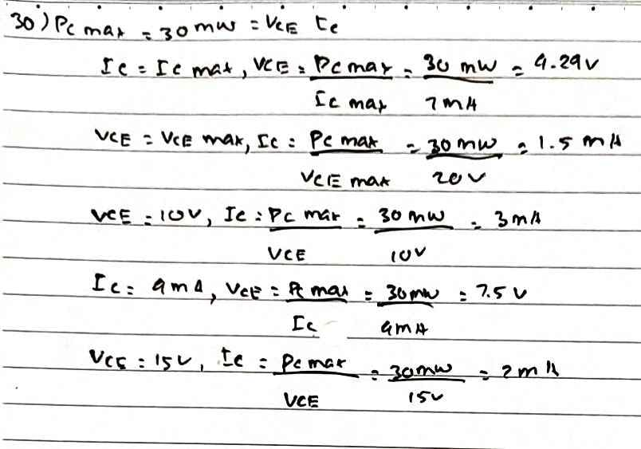
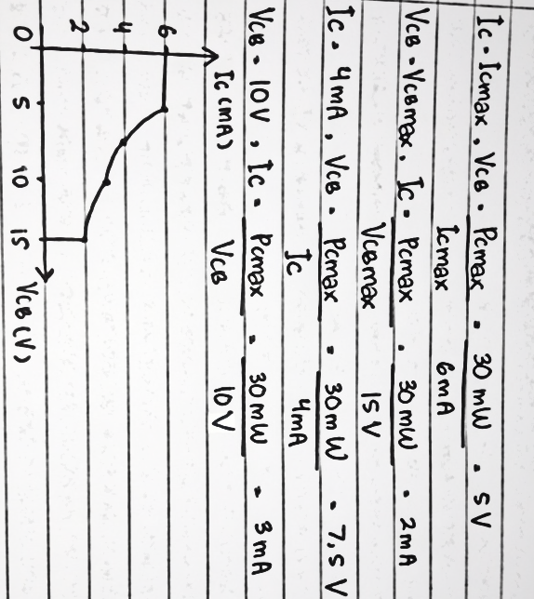
31. Determine the region of operation for a transistor having the characteristics of Fig. 3.8 if ICmax = 6 mA, VCBmax = 15 V, and PCmax = 30 mW.

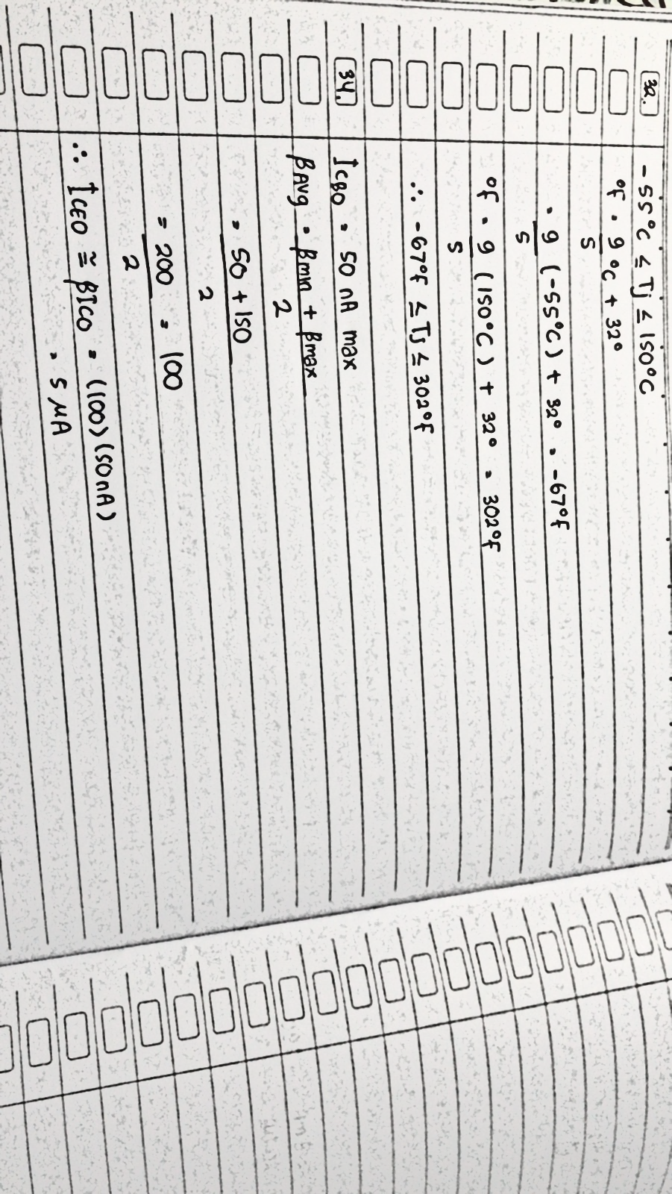
32. Referring to Fig. 3.23, determine the temperature range for the device in degrees Fahrenheit.

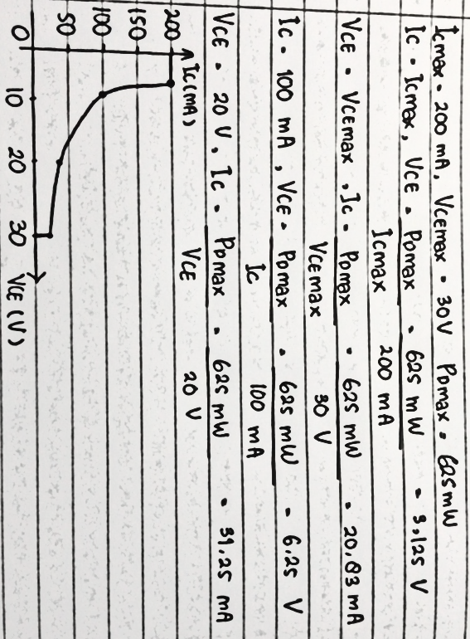
33. Using the information provided in Fig. 3.23 regarding PDmax, VCEmax, ICmax and VCEsat, sketch the boundaries of operation for the device.

34. Based on the data of Fig. 3.23, what is the expected value of ICEO using the average value of βdc?

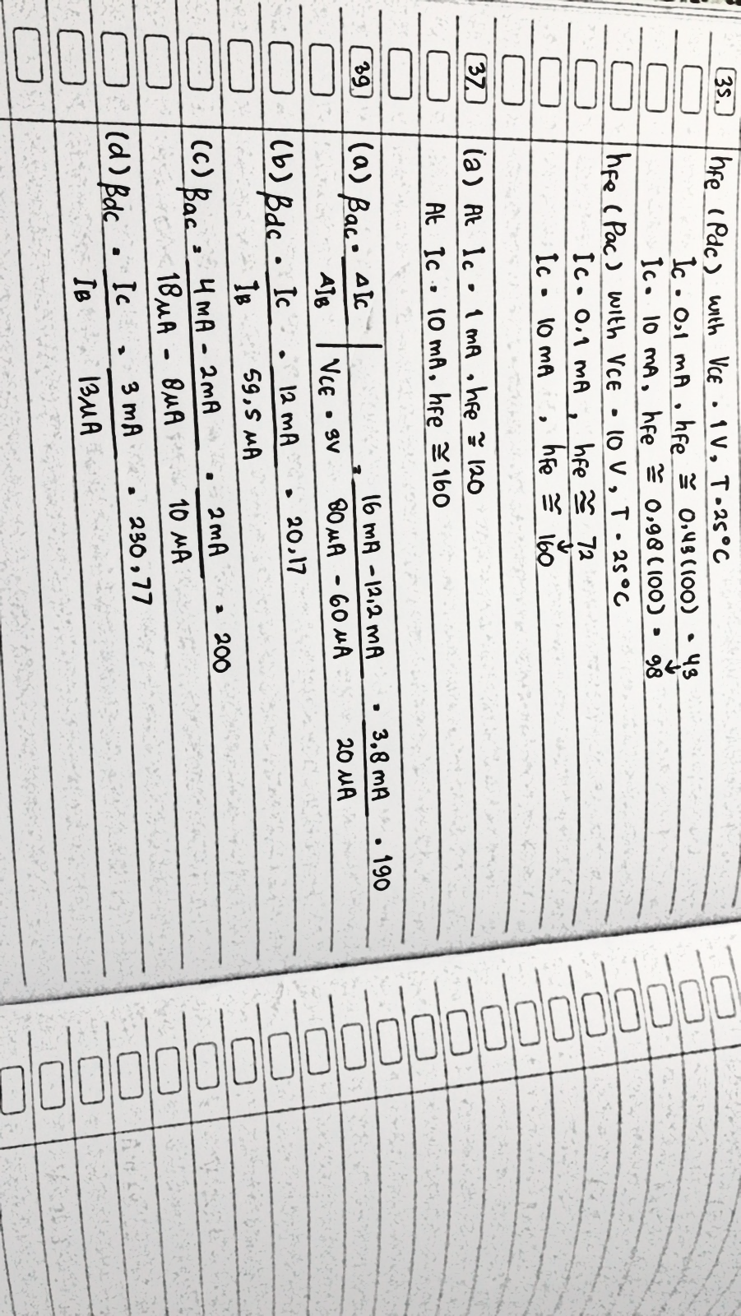
35. How does the range of hFE (Fig. 3.23(j), normalized from hFE = 100) compare with the range of hfe (Fig. 3.23(f)) for the range of IC from 0.1 to 10 mA?

36. Using the characteristics of Fig. 3.23b, determine whether the input capacitance in the common-base configuration increases or decreases with increasing levels of reverse-bias potential. Can you explain why?
Jawab : Ketika potensi bias balik meningkat besarnya, kapasitansi input Cibo berkurang (Gbr. 1). 3.23(b)). Peningkatan potensi bias balik menyebabkan lebar daerah penipisan menjadi meningkat, sehingga mengurangi kapasitansi ( $∁ =$ $ε \frac{A}{d}$ ) .
37. Using the characteristics of Fig. 3.23f, determine how much the level of hfe has changed from its value at 1 mA to its value at 10 mA. Note that the vertical scale is a log scale that may require reference to Section 11.2. Is the change one that should be considered in a design situation?
Jawab :

( b ) Hasil tersebut mengkonfirmasi kesimpulan dari soal 21 dan 22 bahwa beta cenderung meningkat dengan meningkatnya arus kolektor.
38. Using the characteristics of Fig. 3.23j, determine the level of βdc at IC = 10 mA at the three levels of temperature appearing in the figure. Is the change significant for the specified temperature range? Is it an element to be concerned about in the design process?
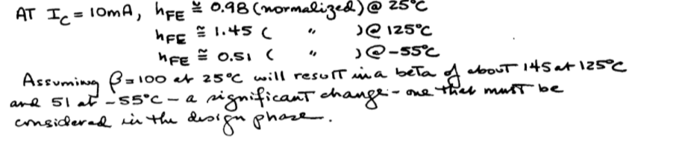
39. (a) Using the characteristics of Fig. 3.24, determine ac at IC = 14 mA and VCE = 3 V.
(b) Determine βdc at IC = 1 mA and VCE = 8 V.
(c) Determine βac at IC = 14 mA and VCE = 3 V.
(d) Determine βdc at IC = 1 mA and VCE = 8 V.
(e) How does the level of βac and βdc compare in each region?
(f) Is the approximation βdc $≅$ βac a valid one for this set of characteristics?
(e) Dalam kedua kasus βdc sedikit lebih tinggi dari βac ($≅$10%)
(f) (g)
Secara umum βdc danβ ac meningkat dengan meningkatnya IC untuk VCE tetap dan keduanya menurun untuk penurunan tingkat VCE untuk IE tetap. Namun, jika IC meningkat sementara VCE menurun ketika bergerak di antara dua titik pada karakteristik, peluangnya adalah tingkat βdc atau βac mungkin tidak berubah secara signifikan. Dengan kata lain, peningkatan yang diharapkan karena peningkatan arus kolektor dapat diimbangi dengan penurunan VCE. Data di atas mengungkapkan bahwa ini adalah kemungkinan yang kuat karena level β relatif dekat

